Adafruit PiOLED 128x32 Mini OLED

May 27, 2018

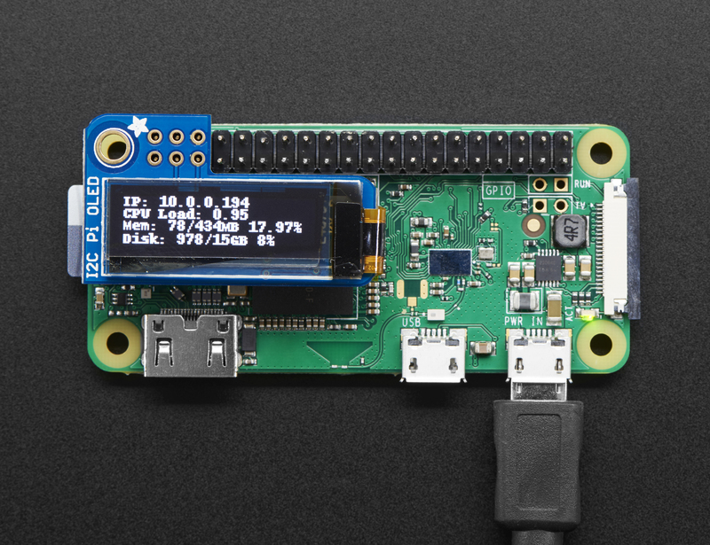

Install Instructions:

<https://learn.adafruit.com/adafruit-pioled-128x32-mini-oled-for-raspberry-pi?view=all>

Adafruit provides a python library (see above link)

However what if you want something more C like?

It took awhile to find libraries that were written for the smaller 0.96” (128x32) OLEDS.

Most of the libraries I found are written for the larger 1.2” OLEDs

Here is what I found:

<http://hallard.me/adafruit-oled-display-driver-for-pi/> (Information)

<https://github.com/hallard/ArduiPi_OLED> (There is a small issue with this library appears on a PI Zero W)

Here is the issue:

<https://github.com/hallard/ArduiPi_OLED/issues/19>

BrodyUW has a work around:

### [brodyUW](https://github.com/brodyUW) **commented [24 days ago](https://github.com/hallard/ArduiPi_OLED/issues/19#issuecomment-386208036)**

| Found a simple work around, posted below.  Not very experienced here, but I have been fighting this same issue for quite a few hours over the past week. Every time I ran "sudo make" in the main folder, Makefile would exit with an error on line 54: ld can't find -li2c. I am running Raspbian Lite Stretch on RPi Zero W. I tried installing the deb packages recommended above, but also got the "illegal instruction" error on execution.  Not sure what changed, but invoking -li2c with g++ in the Makefile should link to libi2c.so or libi2c.a; however, after installing libi2c-dev via apt, no such library exists. bcm2835.c has the following line: "#include <linux/i2c-dev.h>". I am assuming with -li2c, ld should be able to find that header file, but it can't. So I simply modified the main Makefile by removing -li2c and using the -I option to specify the location and file to include. Everything now compiles and the I2C OLED examples work perfectly.  Again you are looking for line 54 in the main Makefile. Below I have posted line 53 and 54. I commented out the -li2c flag and added the -I option. I hope this works for everybody else.  ArduiPi_OLED: ArduiPi_OLED.o Adafruit_GFX.o bcm2835.o Wrapper.o  $(CXX) -shared -Wl,-soname,$(LIB).so.1 $(CFLAGS) $(LDFLAGS) -o ${LIBNAME} $^ -I:/usr/include/linux/i2c-dev.h #-li2c |
| --- |

 3 1

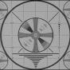

### [kd8bxp](https://github.com/kd8bxp) **commented [9 days ago](https://github.com/hallard/ArduiPi_OLED/issues/19#issuecomment-390371451)**

| [@brodyUW](https://github.com/brodyUW) Thank you for the work around -  I might add to your instructions DO NOT install the above .deb files - they just caused problems for me  running a full install of Stretch on a RPi Zero W - but now I have a working display. Thank you. |
| --- |

 1



### [brodyUW](https://github.com/brodyUW) **commented [8 days ago](https://github.com/hallard/ArduiPi_OLED/issues/19#issuecomment-390375570)**

| [@kd8bxp](https://github.com/kd8bxp) You are welcome! It was very frustrating, but I suppose a valuable learning experience. Good point on the .deb files. |
| --- |

The oled_demo.cpp in the examples directory works with no issues after the above fix is used.

Teleinfo-oled.cpp - not sure what it does, I think it has something to do with serial communication over USB maybe(?)

This is a fork of the above project:

<https://github.com/mozram/ArduiPi_OLED>

It has a directory named modules which has some more working examples

A billboard and sysstat

A few notes about these programs -

They need to run as sudo, they all have options to tell which display to use.

-o 2 most have a help screen --help

Billboard doesn’t need the -o 2 option.

Another library (written by the same author above, and maybe an older version)

<https://github.com/hallard/ArduiPi_SSD1306>

I didn’t have any issues with this one.

The examples all work, they need the -o 2 option to work with this display.

Other Information:

My Raspberry PI IP address has been (192.168.0.32, or 96OLED.local)

LIbraries that don’t work with this screen but probably work with the bigger 1.3” OLEDs.

<https://learn.adafruit.com/ssd1306-oled-displays-with-raspberry-pi-and-beaglebone-black?view=all>

<https://projects.drogon.net/raspberry-pi/wiringpi/i2c-library/>

<https://github.com/nopnop2002/ssd1306_rpi>

<https://github.com/JackHuang21/ShowRaspberryInfo>

<https://github.com/kjhughes097/pi-ssd1306-oled>

<https://kapie.com/2016/ssd1306-128x64-bit-oled-display-interfacing-with-raspberry-pi/>

<https://github.com/boyanov/libssd1306i2c_raspi>

<https://github.com/iwjy/raspberry-pi-oled>